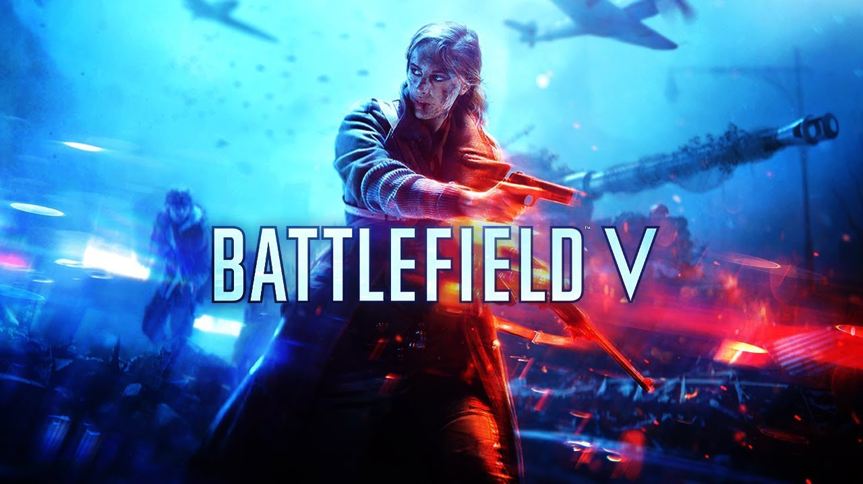

**BATTLEFIELD V**

**Developed By:** [DICE](https://www.google.com/search?sa=X&bih=625&biw=1366&hl=en&sxsrf=AOaemvIsyx8mTFhlsK-lF_oOWV5Ga3BosA:1640622914654&q=EA+DICE&stick=H4sIAAAAAAAAAOPgE-LVT9c3NEwzMzEvykvOVeLUz9U3MEo3LTPSUslOttJPLkvXT87PLSgtSS2KL8tMSc1PT8xNtUpJLUvNyS9ILVrEyu7qqODi6ey6g5URAF2ZEgpPAAAA&ved=2ahUKEwjf0KbQtIT1AhWJLewKHYxHAu4QmxMoAXoECDYQAw)

**Description:** Battlefield V is a first-person shooter video game developed by DICE and published by Electronic Arts. Battlefield V is the sixteenth installment in the Battlefield series and the successor to 2016's Battlefield 1.

**Platforms:** PlayStation 4, Xbox One, Microsoft Windows

**System Requirement:**

* A minimum computer system that will help you access all the tools in the courses is a Pentium 166 or better.
* 64 Megabytes of RAM or better.

**Published By:**

